CHINMAYA INTERNATIONAL RESIDENTIAL SCHOOL
COIMBATORE

SAMPLE PAPER – 2010

CLASS : VII SUBJECT: MATHEMATICS

- What is the ratio formed from the following figure?
 | 

(a) 2 : 3 (b) 3 : 2 (c) 2: 1 d) none of these

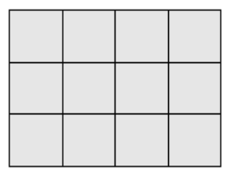
- Find the perimeter of the following figure (each small square has side 1 cm):

(a) 12 sq. cm (b) 14 sq. cm (c) 7 sq. cm (d) none of these
- Rajesh leaves school at 5.30 p.m. It takes him 75 minutes to reach home.

At what time does he reach home?

(a) 6.45 p.m (b) 6.25 p.m (c) 6.45 a.m (d) none of these
- Algebraic expression for “24 is nine less than three times a number”
(a) 24 x – 3 = 9 (b) 3x – 9 = 24 (c) 9x – 3 = 24 (d) none of these

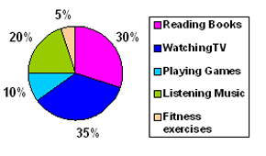
- The Pie Chart shows the favorite leisure time activities of about 200 people living in the Anna Street.

Which activity is preferred by most of the people?

(a) Reading books (b) Watching TV (c) Playing games (d) Listening Music

